Audubon Park Volunteer Fire Department 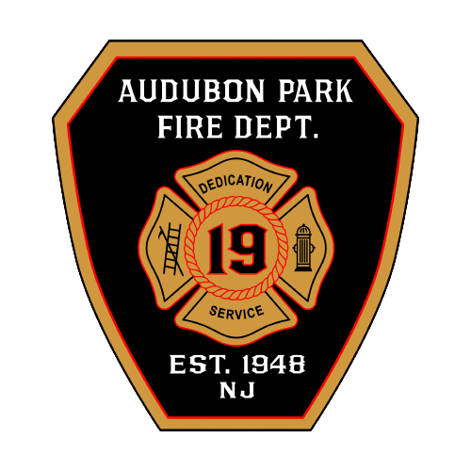

18 Road C

Audubon Park NJ, 08106

856-546-6134

**Application for Membership**

Audubon Park Fire Department is an equal opportunity fire department, and is committed to excellence in diversity. Membership appointments are made without regard to race, sex, religion, national, or ethnic origin, disability, age, veteran status, or sexual orientation.

**Please Print**

Complete the entire application. You may attach a resume, but you must still complete all questions; or your application will be deemed incomplete and may not be considered. Please fill out each box (don't just indicate “See Resume.”)

| **Position Applying For**  Firefighter [ ]  JR. Firefighter [ ]  Associate Member [ ]  Fire Police [ ] | **Name(Last, First, Middle):** | | | | | |
| --- | --- | --- | --- | --- | --- | --- |
| **Street Address:** | | | | | **City, State, Zip Code:** | |
| **Social Security #** | | **Date of Birth:** | | | | **Phone Number:** |
| **Are you eligible to work in the US?** | | | **Yes [ ]**  **No [ ]** | **Email Address:** | | |
| **Have you ever been convicted of a felony or misdemeanor?**  **Date Convicted:** | | | **Yes [ ]**  **No [ ]** | **If Yes Explain:** | | |
| **Have you ever been a member of the Audubon Park Fire Department?** | | | **Yes [ ]**  **No [ ]** | **If Yes, dates and reason for leaving:** | | |
| **Have you ever been a member of another fire company or other emergency service?** | | | **Yes [ ]**  **No [ ]** | **If Yes, dates of employment, reason for leaving:** | | |
| **Have you ever been suspended, or terminated from another fire company or other emergency service?** | | | **Yes [ ]**  **No [ ]** | **If Yes, reasons for disciplinary action:** | | |
| **Are you related to any current company member?** | | | **Yes [ ]**  **No [ ]** | **If Yes, their Name and relationship to you:** | | |
| **Do you have a valid driver’s license?** | | | **Yes [ ]**  **No [ ]** | **If Yes, please provide a current copy of your license**  **Lic#______________ Date Issued______________** | | |
| **Have you ever had your license suspended or revoked?** | | | **Yes [ ]**  **No [ ]** | **If Yes, explain why:** | | |

**Skills** Please list any technical skills, clerical skills, trade skills, etc., relevant to this position. Include relevant computer systems, and software packages of which you have working knowledge, and note your level of proficiency (basic, intermediate, expert).

**Education**

| **Name of School** | **City/State** | **Did you graduate?** | **If no # of years left to finish** | **If yes date of Graduation** | **Degree Received** | **Major** |
| --- | --- | --- | --- | --- | --- | --- |
| **High School:** |  | **Yes [ ]**  **No [ ]** |  |  |  |  |
| **GED:** |  | **Yes [ ]**  **No [ ]** |  |  |  |  |
| **Other School:** |  | **Yes [ ]**  **No [ ]** |  |  |  |  |
| **College:** |  | **Yes [ ]**  **No [ ]** |  |  |  |  |

**Work experience-** Please listcurrent employer

**Please note:** The Audubon Park Fire Departmentreserves the right to contact your current employer for reference information.

| Dates Employed (most recent position)  From: To: | [ ] Full Time [ ]Part Time  If part time #hrs./wk: __________ | Title: | |
| --- | --- | --- | --- |
|  | Organization Name & Address | | |
|  |
| Supervisors Name, Title, and Phone # | Other Reference Name, Title, and Phone# | | Contact my current reference [ ] At any time [ ] Not at this time |
| Primary Duties: | | | Reason for leaving: |

**References-** Please list two (2) references not related to you, who have definite knowledge of your business or professional qualifications for the position of volunteer firefighter. Do not repeat names of supervisors listed under employment.

| **Name** | **Address** | **Phone** |
| --- | --- | --- |
|  |  |  |
|  |  |  |

PLEASE READ CAREFULLY AND SIGN THAT YOU UNDERSTAND AND ACCEPT THIS INFORMATION. I certify that the information on this application and its supporting documents is accurate and complete. I understand and agree that failure to fully complete the form, or misrepresentation or omission of facts, represents grounds for elimination from consideration for membership, or termination after being accepted if discovered at a later date. I authorize the **Audubon Park Fire Department** to investigate, without liability, all statements contained in this application and supporting materials. I authorize references and former employers, without liability, to make full responses to any inquiries in connection with this application for membership. If requested, I agree to submit to a physical exam, criminal and credit background investigation, and/or screening for illegal substances upon conditional offer of membership. If I am accepted, I will be required to furnish proof of eligibility to work in the United States, and to comply with company and departmental regulations. I understand that the first YEAR of Membership represents a probationary period, during which I would have to complete Firefighter 1, unless already obtained.

Applicant Signature: _______________________________________ Date: ______________________

Audubon Park Volunteer Fire Department 

18 Road C

Audubon Park NJ, 08106

856-546-6134

**APPLICATION OF A MINOR AND CONSENT OF THE PARENTS FOR MEMBERSHIP AS A JUNIOR FIREMAN**

I __________________________ of _____________________________________________

**Full Name Address**

Being the age of _____ years, do hereby make applications to become a Junior Fireman in the **Audubon Park Fire Department**. I do hereby agree to be bound by and to conform and comply with all of the rules and regulations and the Constitution of the **Audubon Park Fire Department** and I do hereby submit this application for Junior membership together with the written permission and consent of my parents or legal guardians whose signatures are affixed hereto.

_______/______/_______ **Date**  ___________________________ **Signature**

We ______________________________ and ____________________________________ of

**Parent or Legal Guardian Parent or Legal Guardian**

**_________________________________________, ________________________________________,** New Jersey

**Street Address Town**

**________________________________,** of the applicant, do hereby waive any and all rights and claims

**Relationship to Applicant**

Which we may have as _______________________ by reason of any and all injuries which

**Parent or Guardian**

___________________________ may sustain as a junior firefighter of the **Audubon Park Fire Dept.**

**Name of Applicant**

And we do hereby further release the **Audubon Park Fire Department** and the **Borough of Audubon Park** from any and all liability whatsoever over which they may now or in the future have or incur by reason of injuries sustained by __________________________ while he or she is engaged in furtherance of  **Name of Applicant**

their training, duties, or activities of a Junior Fireman with the **Audubon Park Fire Department.**

**________________________________ ______________ Parent(s) Signature Date**